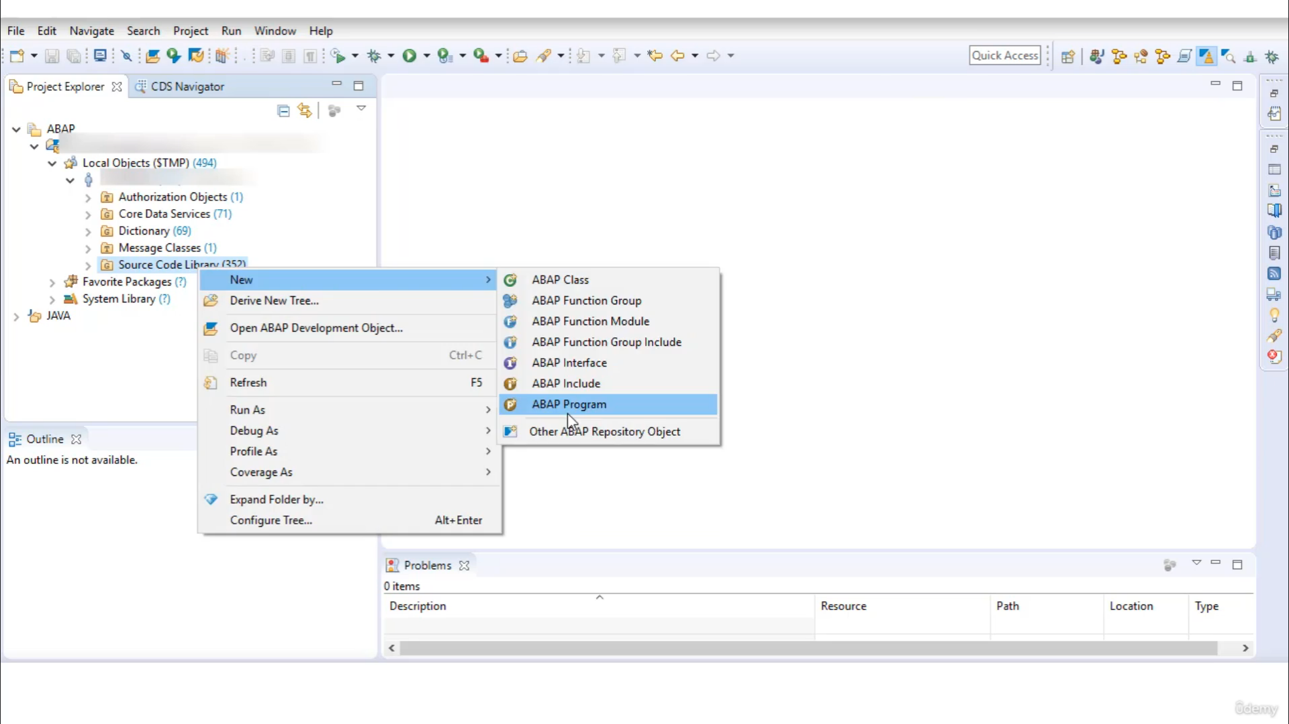

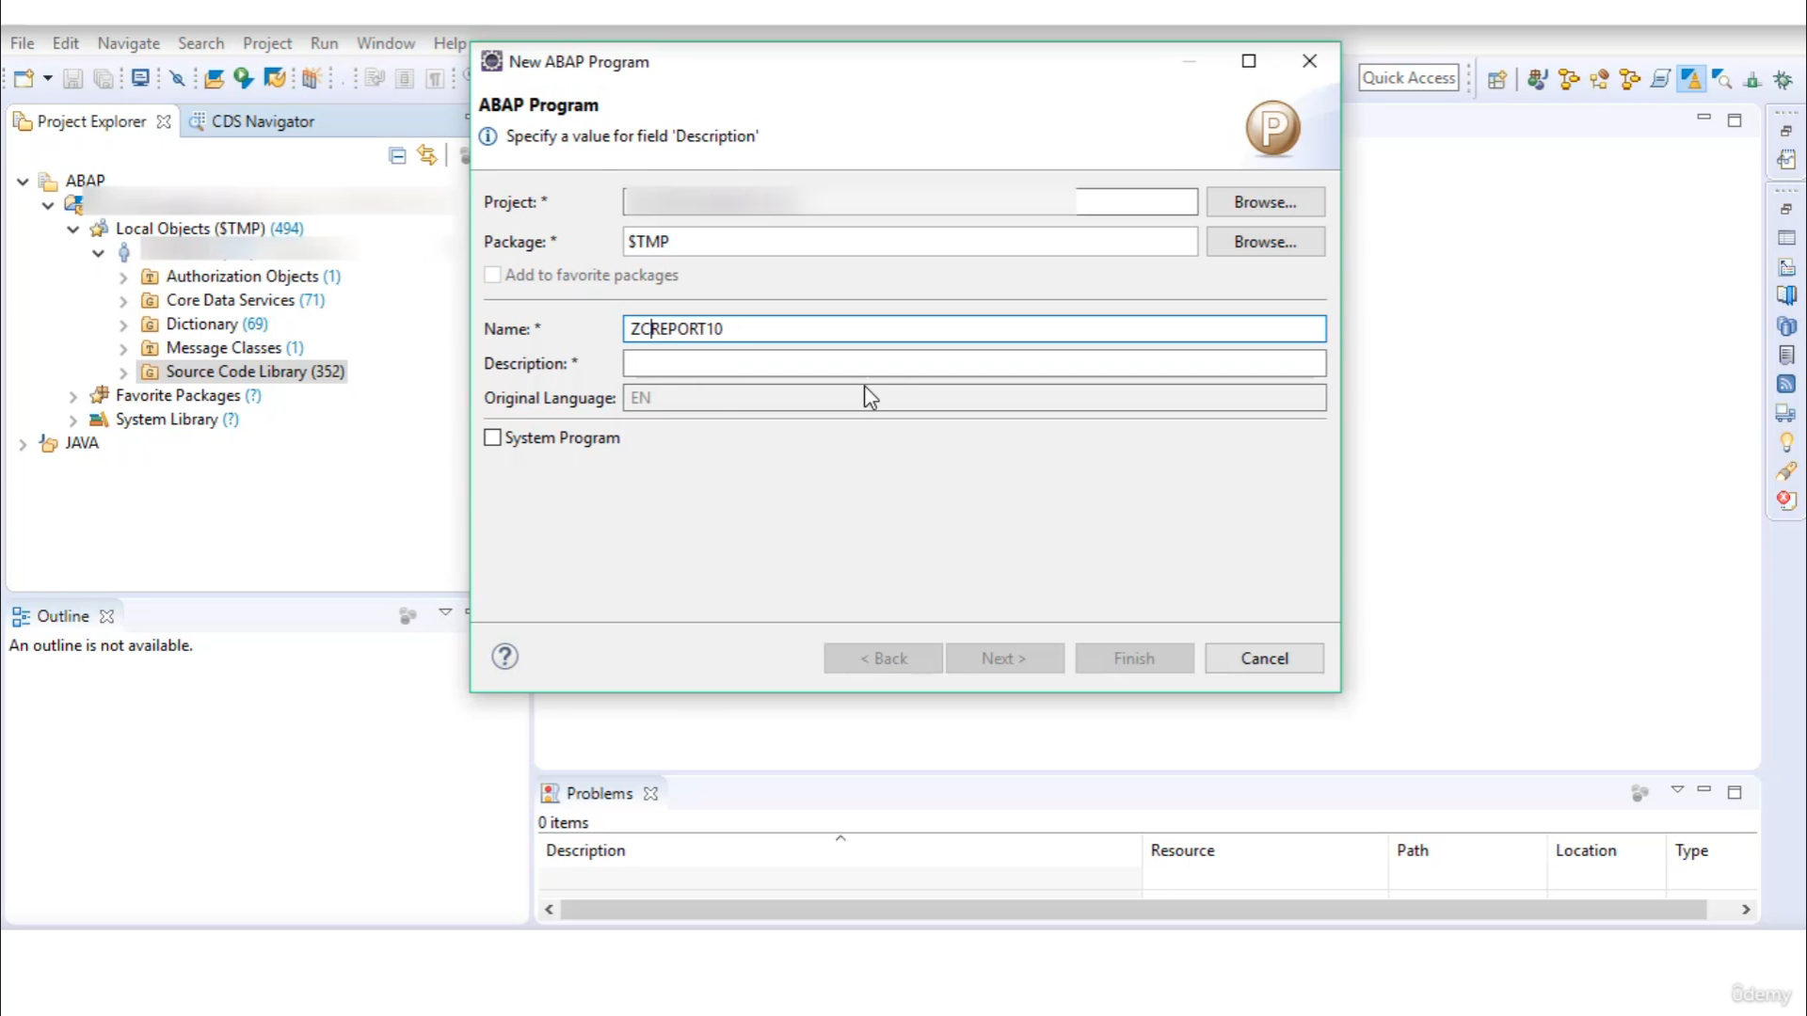

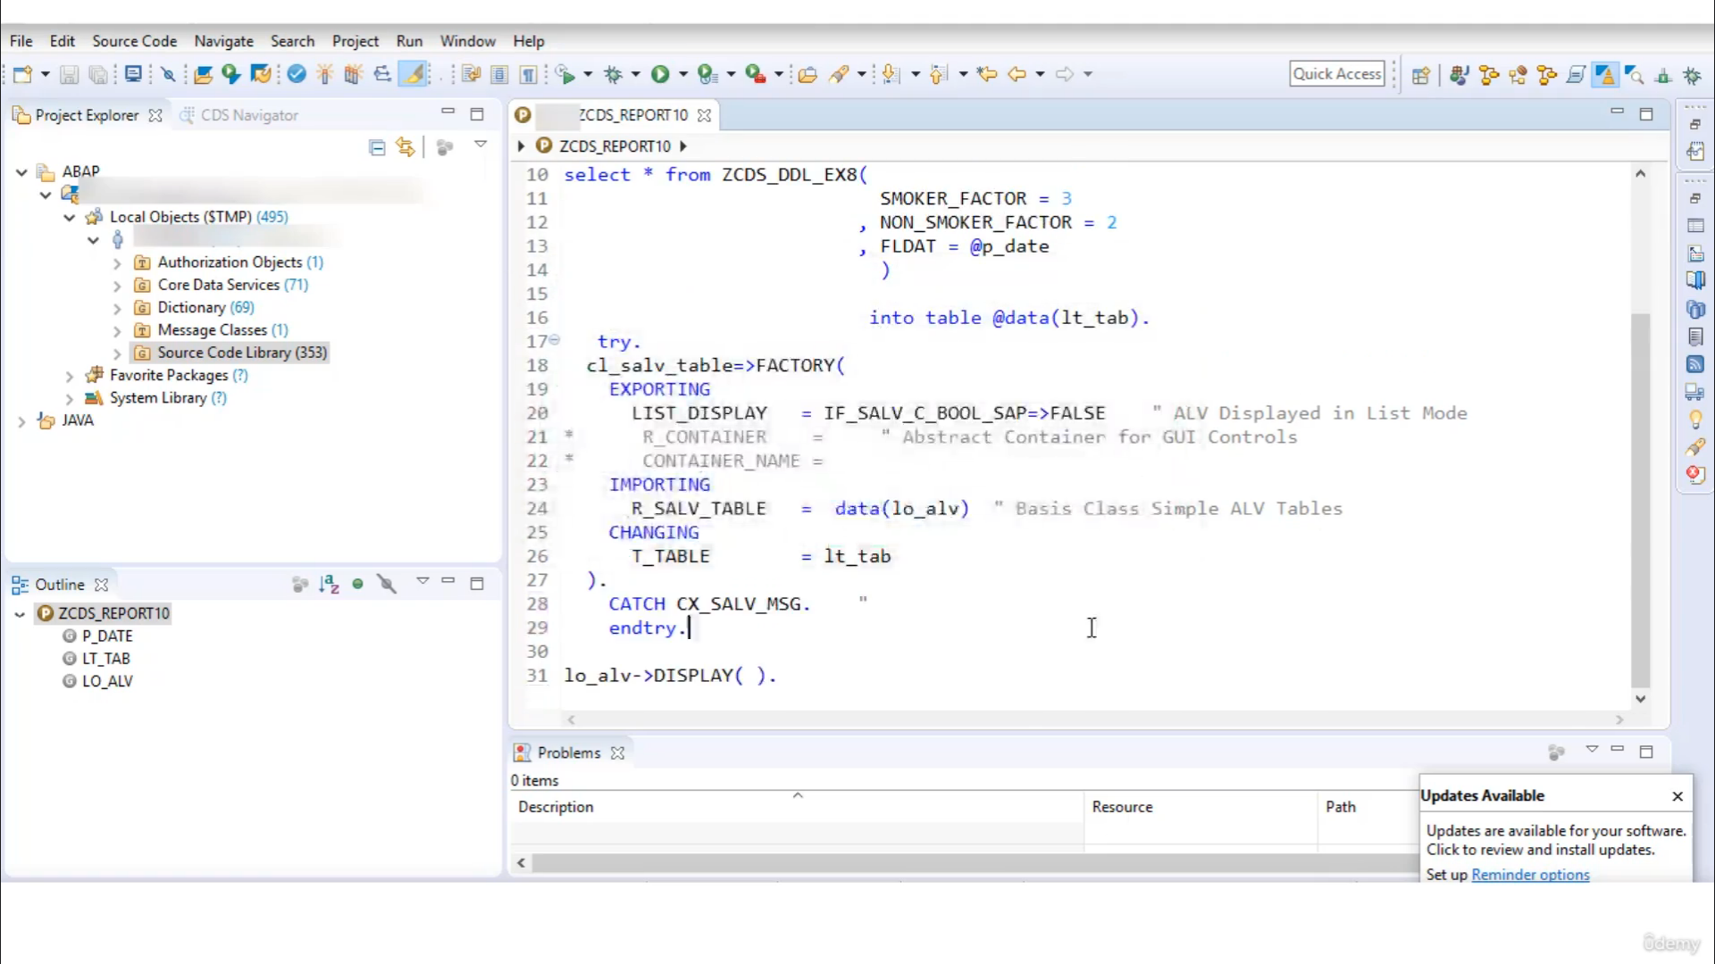

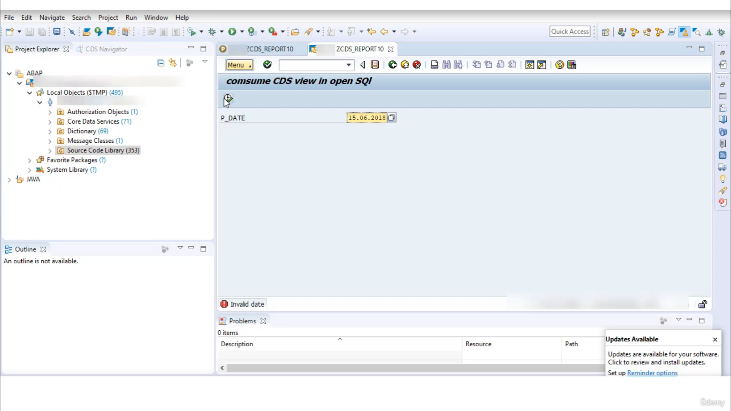

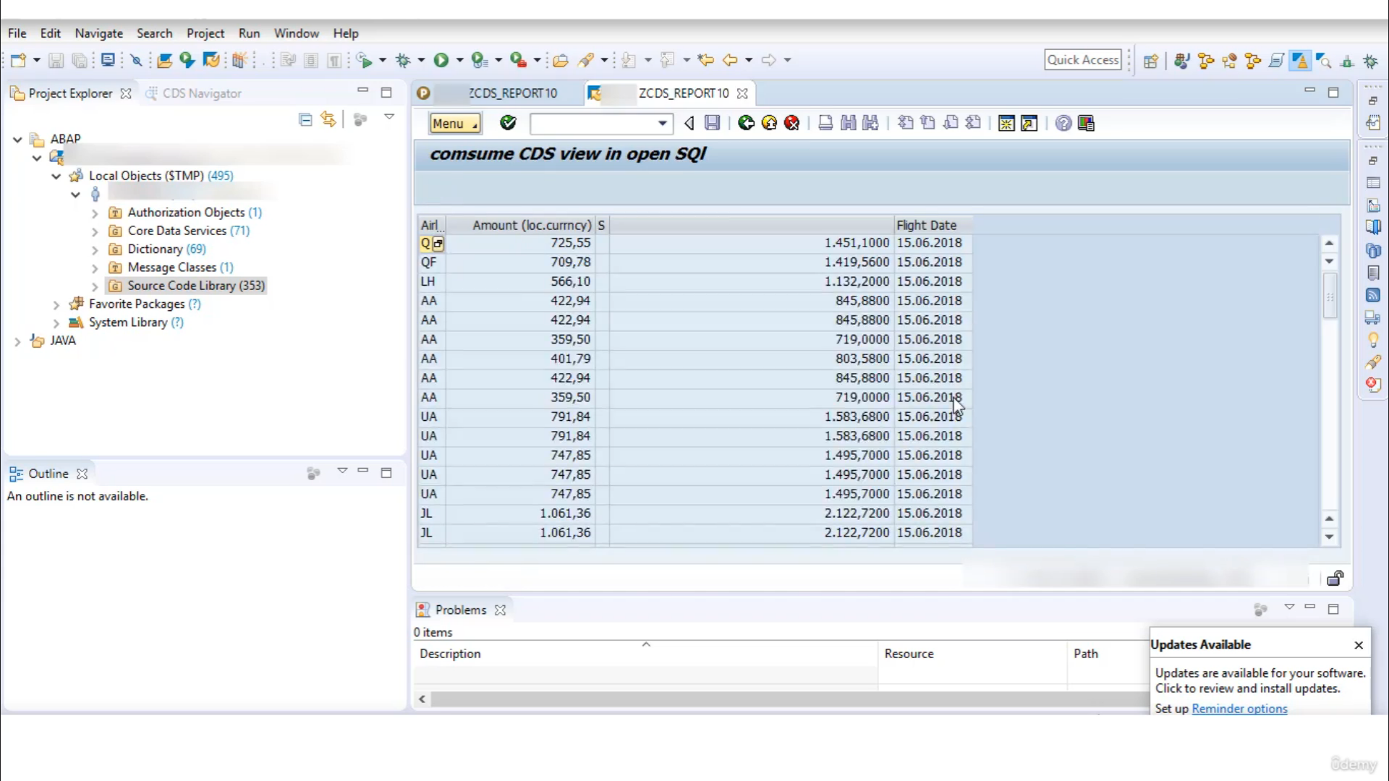

Now, let's get on our program to create a better program to go to school library and then select a

program.

Let's quickly give it Nimetz serious report, then description as serious review in open school.

Let's say I want to use one of mouth previously created serious razzle dazzle, and I want to read all

different from that city's civil rights.

Let's start the name of serious view.

I will use one shortcut here to automatically fill the code once you write the city's new name, just

press control space.

And here is the shortcut to insert full signature.

You have to shift and shift into all the signature related to that series, which will appear in my

report program.

So I want to read all different from this issue, so I will read the actual value to this input parameter.

OK, now, whatever you do here, I will create one parameter.

We did of type of date, and I will pass that parameter to this parameter of today's flight, they'd

still be dead.

So you will see you wonder if the new open is causing death issues.

It must be used throughout this, include using Ateret to escape Hosta variable.

So that means in new openness, squill, if you want to use other variables, then you have to escape

that variable with a direct saying so.

Now delete all of it from this table into a table and discuss that again.

Here you have to use I to say, OK, now everything looks perfect to display or put forward and then

select query.

I will use class SLV table and I will call Method Factory to insert signature of metal factory.

Go to press ship, enter through this parameter required OK.

And you will be required to object to capturing stance for that purpose.

Again, I will use in language a declaration.

If you have to pass this table here.

Now, using object LLB, I will call Mr..

Display paedos signature.

OK, so now everything look fine, activate.

And Ron.

And execute.

And here they are put up over the report program.

Now, let's say if you don't want to fetch Oldfield's from our website issue, then you can write the

fragments directly your amount and it all.

You make sure that since we are to use your new openness syntax, we are separating you with comma.